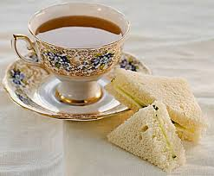
Evening Tea Menu

Home-Made Chicken Goujons
Tossed Baby Leaves, Tomato, Onion and Cucumber
Homemade Potato Salad & Coleslaw

Served with a selection of dips:
Garlic Mayo, Chilli Sauce, Lemon Aioli

*****************

Selection of Sandwiches Made To Order
Selection of Homemade Breads
Soda Farls, Yeast Rolls

*****************

Selection of Cakes, Pastries and Biscuits

*****************

Tea/Coffee

