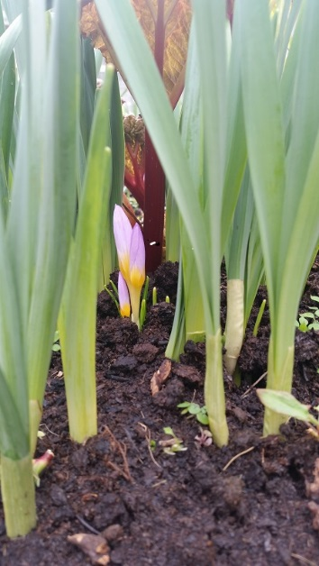
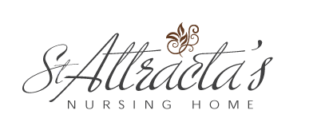

St. Attracta’s Nursing Home Newsletter
Spring 2015
RECENT EVENTS

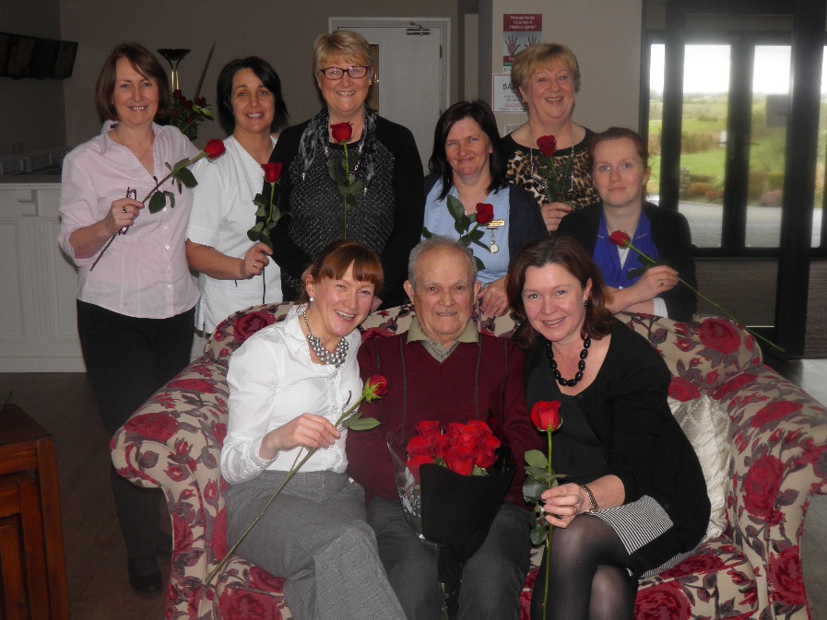
Valentine’s Day
Valentine’s Day was celebrated with a lot of romance in the air at St. Attracta’s. The residents enjoyed a special Valentines menu. Partners of residents were invited to join them for lunch. Chocolates and roses were in abundance and one regular visitor Jim displayed his appreciation for all the ladies of the nursing home, especially his wife Ann by bringing in roses to all. All in all a wonderful day!
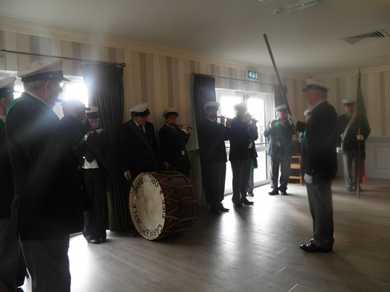
Carracastle Pipe Band
The Carracastle Pipe Band called to visit on Sunday, 8th March to get everyone in the mood for the upcoming St. Patricks Day celebration. As is their style a wonderful display was provided and enjoyed by all. We thank them for their generosity of time.

St. Patricks Day
Whilst many of the residents were unable to attend a parade on St. Patricks Day a flurry of colour and festive spirit was brought into the nursing home.
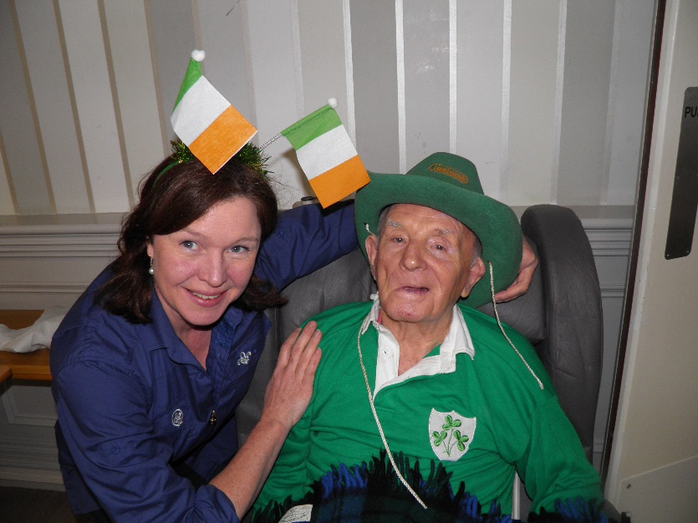

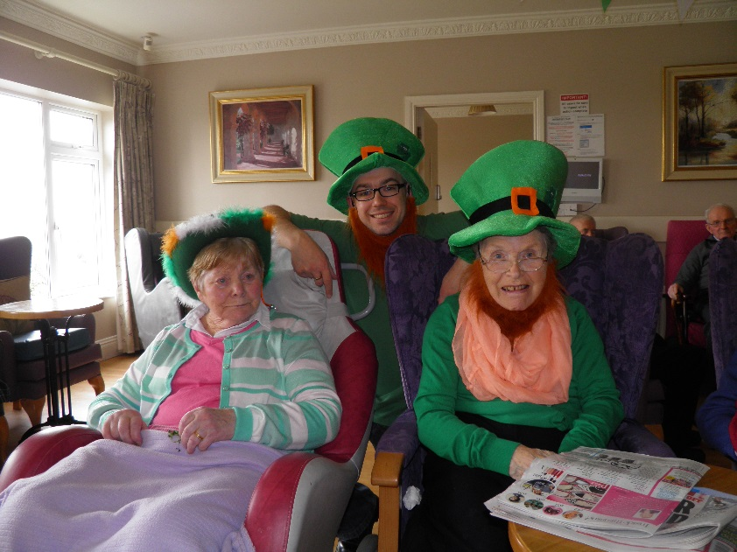
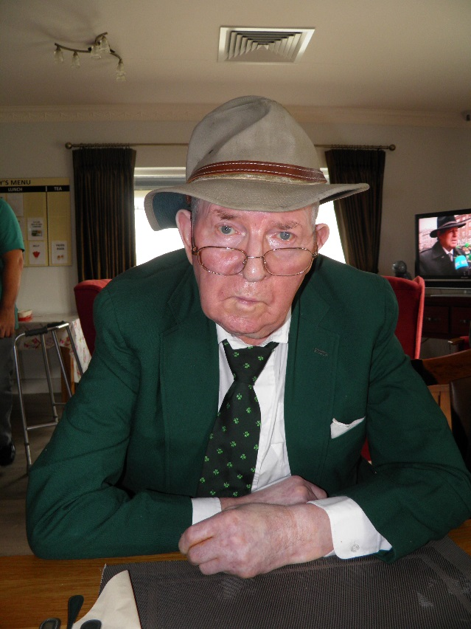

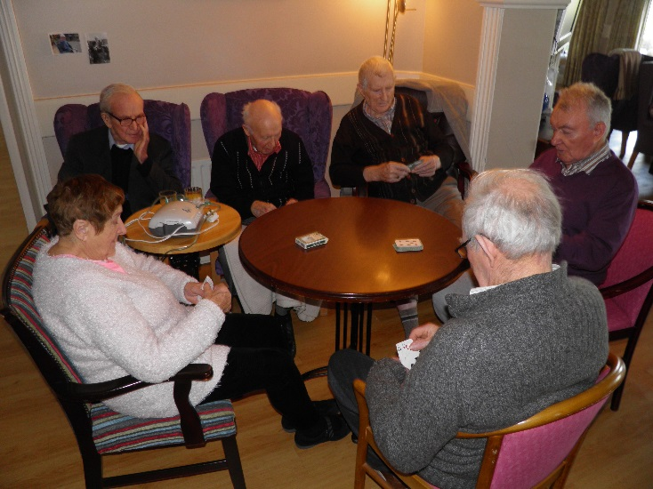
Las Vegas Calling

A snapshot we could not resist sharing. Our own resident card shark Maureen keeping the gents on their toes….

Easter Preparations
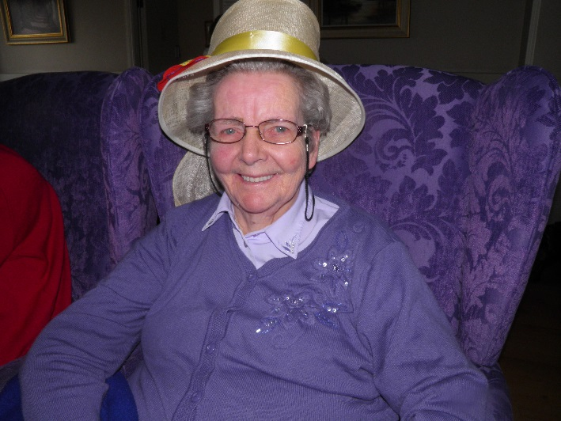
Easter Preparations kept everyone busy in the run up to the Easter weekend in April. The residents decorated a number of Easter bonnets and a flurry of baking activity was underway.
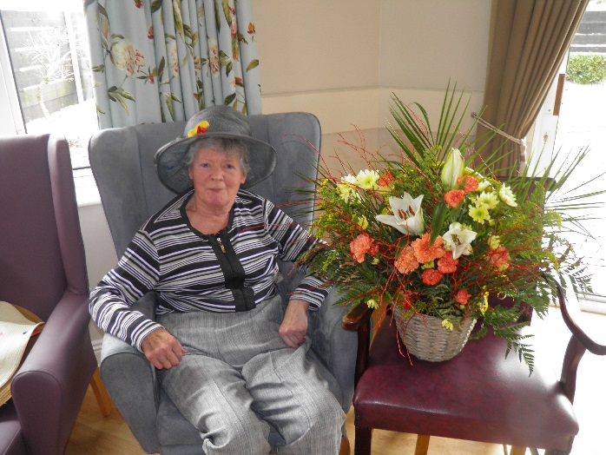
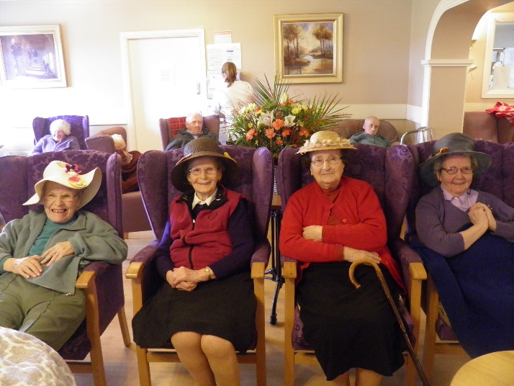
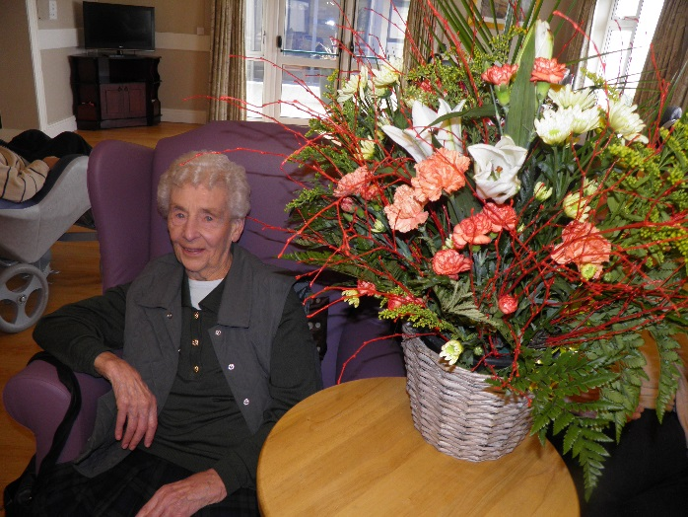

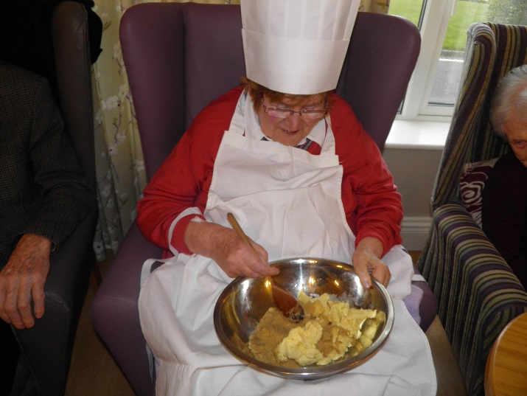
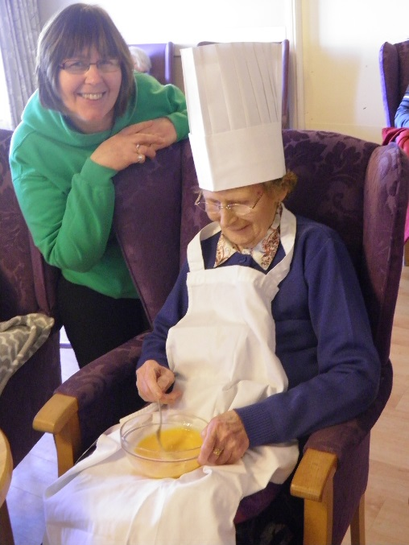
Catering Team
A snapshot of St. Attracta’s Catering Team looking very dapper!
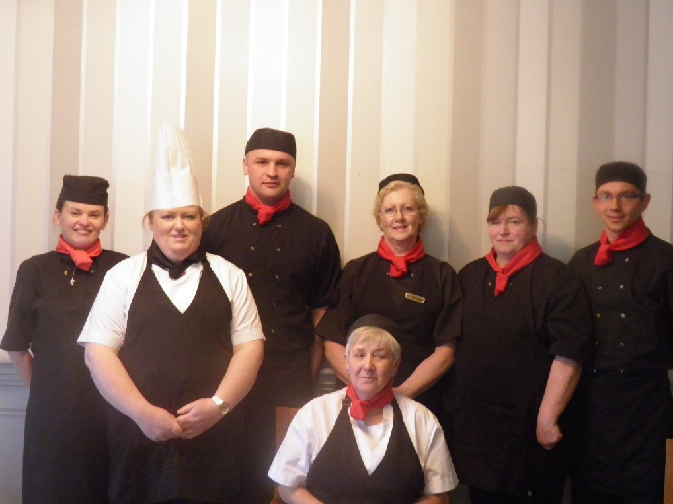
From left to right: Ewelina Konopielko, Aine Roache, Krystof Rusin, Jane Dodd, Marian Murphy, Eileen McLoughlin, Robert Ehlert (Missing from photo Marzena Adamski)
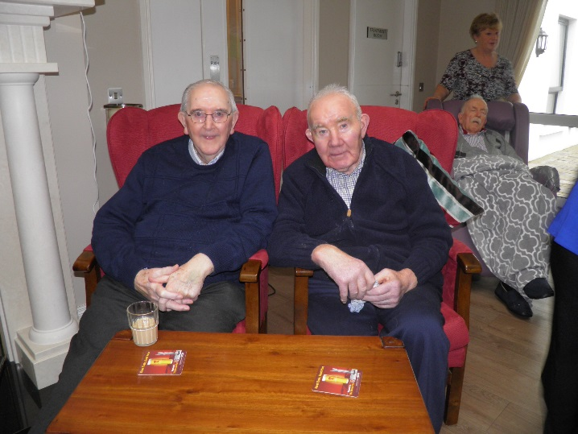
Slainte
The men of the nursing home enjoyed a little taste of ‘Irish’ when the team recreated the pub experience in the nursing home. This was especially enjoyable for many of the residents who were unable to attend the previous pub outings. Music and entertainment and a drop of ‘quare’ stuff was the order of the day and enjoyed by all present.
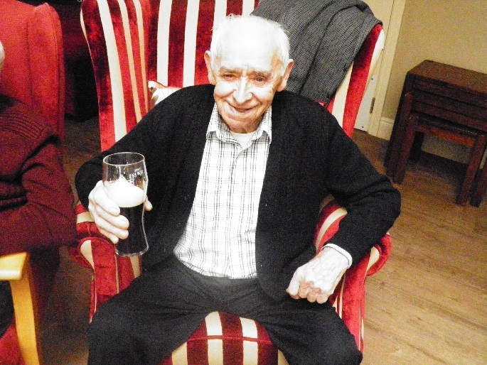
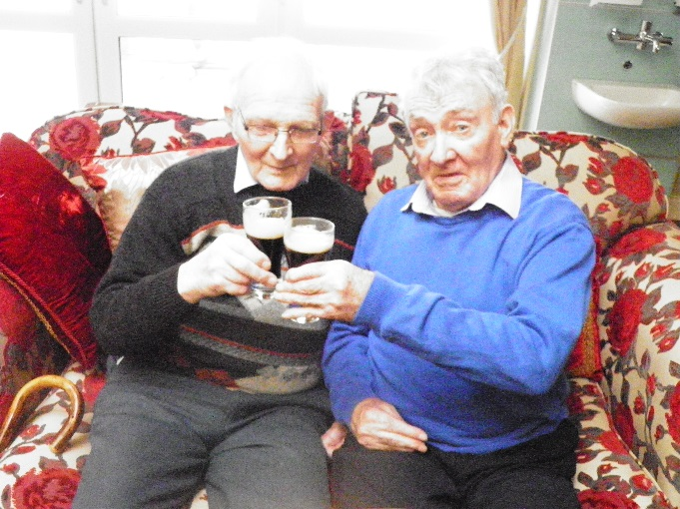

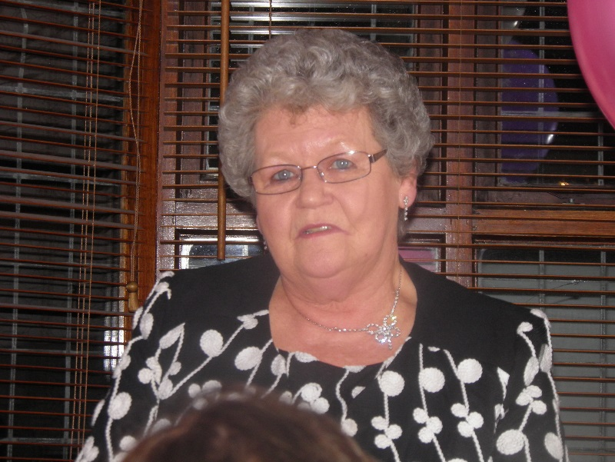
Farewell to Mai
Mai Mulligan was one of the first people employed by Kathleen Donohue when she started caring for the elderly in her own home over 30 years ago. She remained working for Kathleen and moved with the nursing home as it grew and expanded into the sizeable business it is today. Mai worked in a variety of roles devoted to taking excellent care of the residents. Until very recently Mai has continued to work on a weekly basis with the residents. She is loved by residents and staff who will miss her daily presence. This was evidenced by the excellent turn out at her retirement party in April in the Riverside restaurant, Charlestown. Mai has always been a great visitor to the nursing home and we hope she continues this tradition. We wish her every happiness in her well-deserved retirement.

Dates for the Diary
- Throughout May – May Altar and Devotions to Our Lady
- 8th May – Butterfly Company
- 29th May – Exhibition of Residents Art Work at Linenhall Gallery Castlebar
- 22nd – 28th June – Nursing Homes Week which is a week full of events and surprises…the full schedule will be available nearer the time.
- 8th July – Nursing Home Fashion Show – ‘Off The Rails’
- Knock outings – dates to be confirmed

Welcome
Welcome to the new residents who joined us in recent months; Sister Rosario Cogan, John Quinn, John Moran, Thomas Brown and Sean Murrin. We are delighted to welcome you to your new home and hope you are settling in well.

Birthday Celebrations
We’ve had a lot of birthdays over the past few months. The following residents all celebrated birthdays recently:
James Prendergast 8th February Bessie Doherty 14th March
Peter Gallagher 14th February Mary Roddy 22nd March
Maureen Walsh 18th February Margaret Duffy 29th March
Tommy Joe Rochford 19th February Bernadette Cooke 17th April
Mary Lafferty 24th February Mary Kate Walsh 19th April
Tom Harrington 11th March

RIP
Deepest sympathy is extended to their family and friends on the recent passing of Eamon Cullen, Bill Gildea, Ann O’ Donnell, Tom Brett, Maureen Brennan, Evelyn Mulligan, Bridie Quinn, Mary Weaver and Dennis McDonagh. May they rest in peace.

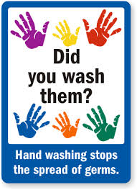
Hand Hygiene Awareness Week
Hand Hygiene Awareness week took place from 5th to 8th of May. Staff attended refresher training on good hand hygiene practice. The objective of this is to reduce any possible cross contamination and to control the transfer of bacteria. Staff are committed to good hand hygiene and you will see this evidence thorough their frequent had washing and use of hand sanitizers. Staff will be proudly wearing badges which encourage residents and visitors to ‘Ask Me Have I Washed My Hands’; please do ask staff as this program is for everyone’s health and wellbeing.

Audit Feedback
The 2014 Annual Review of Quality & Safety of Care has been completed and copies are distributed throughout the nursing home. This is a summary of key aspects of the nursing home service. If you would like more information on any aspects of this document or would like to see other points included in future annual editions please speak with the Director of Nursing, Alison Moore.
The senior management team of the nursing home completed an Audit training program in April which gave additional instruction on the audit processes we use and audit tools. We expect that this will help to enhance the quality of the audits carried out in St. Attracta’s.
In recent months the following audits have been carried out:
- Cleaning Audit – carried out in April 2015.
- Night Duty Checks –carried out in February 2015
- Manual Handling Audit – this was carried out monthly
- Medication Audit – completed to ensure all the practices in management and administration of medication to residents follows the correct procedures.
If you would like more information on monitoring of quality standards at St. Attracta’s Nursing Home please don’t hesitate to ask any member of staff.

St. Attracta’s Team News
We had had a number of new staff join the team in recent months. We heartily welcome these new members to the nursing home team. Farewell to those staff who have left us to move onto pastures new and thank you for your hard work and service.
- Rachel Cassidy – Healthcare Assistant
- Nollaig O’ Dowd – Housekeeper
- An Mary Isaac – Healthcare Assistant
- Kevin Murphy – Healthcare Assistant
- Alina Pugaciov – Housekeeper
- Eva Ginnelly - Healthcare Assistant

Maybe
When I wander
don’t tell me to come and sit down.
Wander with me.
It may be because I am hungry, thirsty, need the toilet.
Or maybe I just need to stretch my legs.
When I call for my mother
(even though I’m ninety!)
don’t tell me she has died.
Reassure me, cuddle me, ask me about her.
It may be that I am looking for the security
that my mother once gave me.
When I shout out
please don’t ask me to be quiet…or walk by.
I am trying to tell you something,
but have difficulty in telling you what.
Be patient. Try to find out.
I may be in pain.
When I become agitated or appear angry,
please don’t reach for the drugs first.
I am trying to tell you something.
It may be too hot, too bright, too noisy.
Or maybe it’s because I miss my loved ones.
Try to find out first.
When I don’t eat my dinner or drink my tea
it may be because I’ve forgotten how to.
Show me what to do, remind me.
It may be that I just need to hold my knife and fork
I may know what to do then.
When I push you away
while you’re trying to help me wash or get dressed,
maybe it’s because I have forgotten what you have said.
Keep telling me what you are doing
over and over and over.
Maybe others will think
you’re the one that needs the help!
With all my thoughts and maybes,
perhaps it will be you
who reaches my thoughts,
understands my fears,
and will make me feel safe.
Maybe it will be you
who I need to thank.
If only I knew how.

