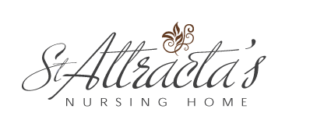

St. Attracta’s Nursing Home Newsletter
Summer 2015
RECENT EVENTS
International Nurses Celebration Day
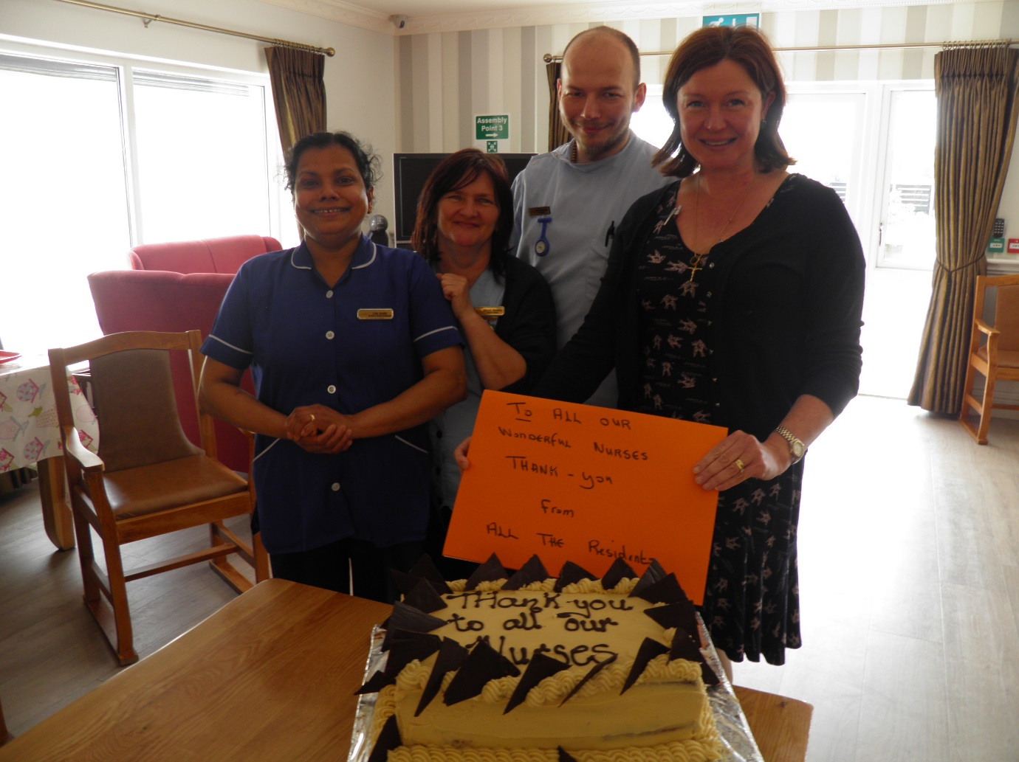
On 12th May we celebrated International Nurses Celebration Day with some lovely cake kindly made by chef Aine. The residents made a lovely card to say thank you to the caring and wonderful nursing team we have at St. Attractas.
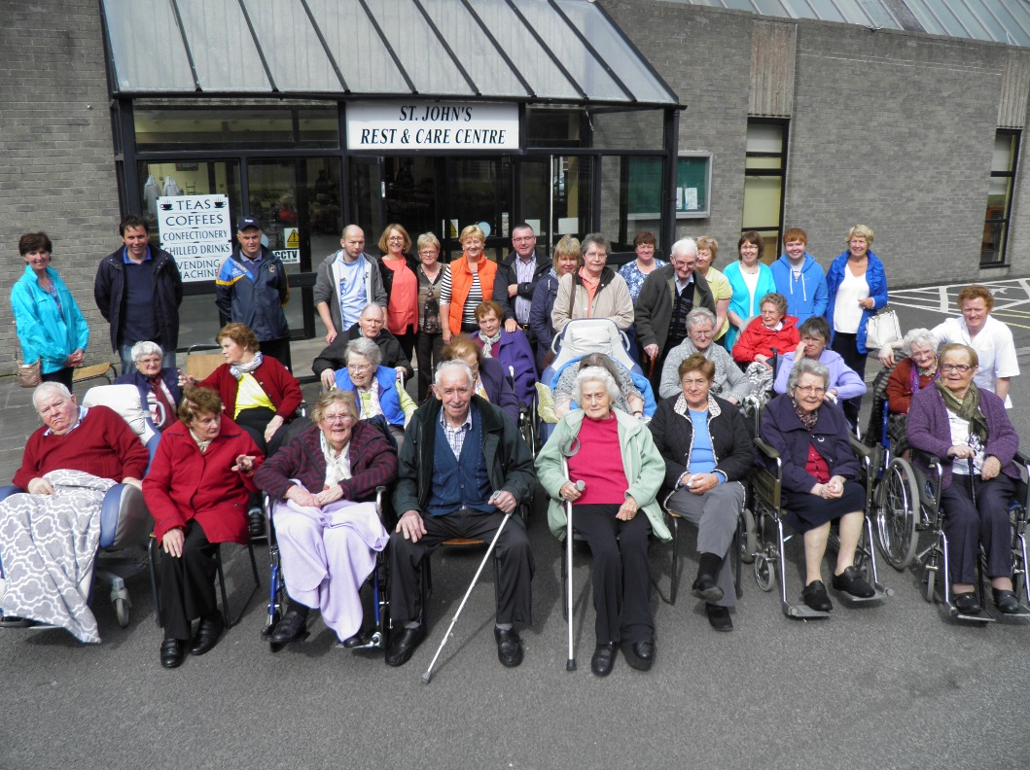
Nursing Homes Week
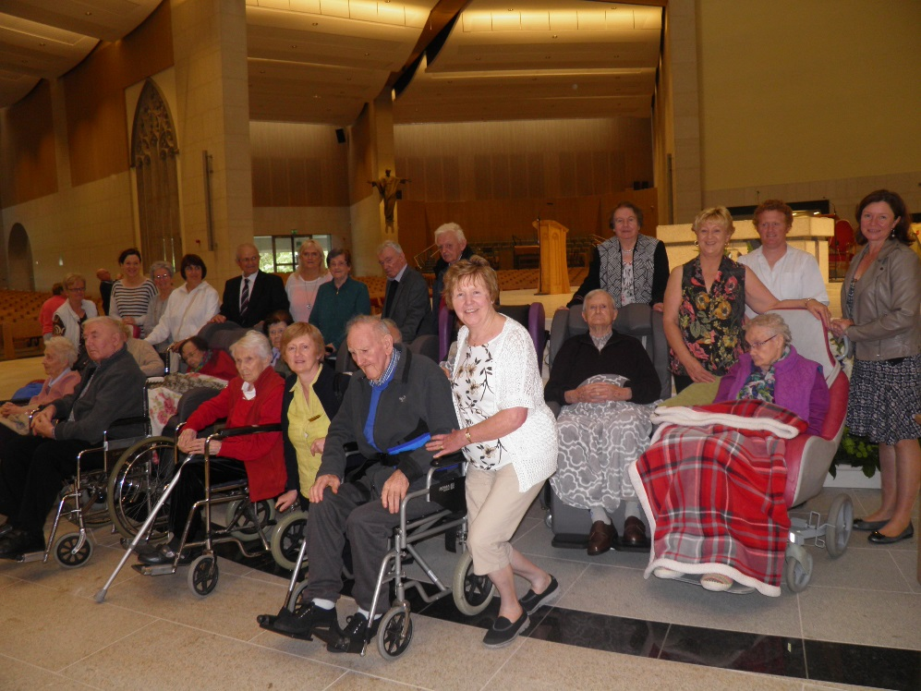
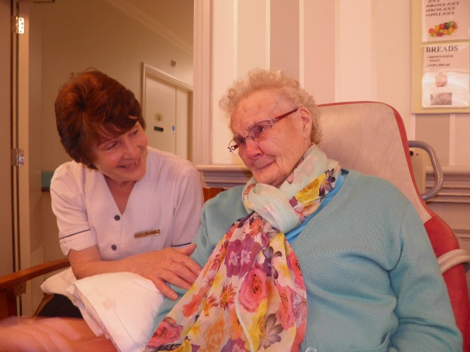
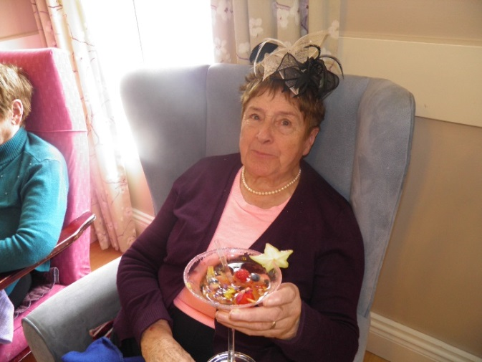
Nursing Homes Ireland week took place from 22nd-28th June 2015. The purpose of the week is to celebrate nursing home life and the care provided by the wonderful staff. The week kicked off to an energetic start with special Olympics Fit for Life where residents were presented with certificates; also there was music and dancing. Ann Meehan of Charlestown came with a display of millinery and the afternoon was especially enjoyed with an array of colourful cocktails. Two groups of residents, staff and family members went on two outings to Knock Shrine and thankfully the weather held so that they were able to enjoy the occasion. The ladies enjoyed an afternoon of pampering with Monica Parsons on hand to beautify. The pampering was accompanied by copious amounts of Baileys and chocolates to add to the festive feeling. Sister Anne and Sister Leo from Tubbercurry Marist Sisters provided a wonderful afternoon of musical entertainment, singing and dancing.
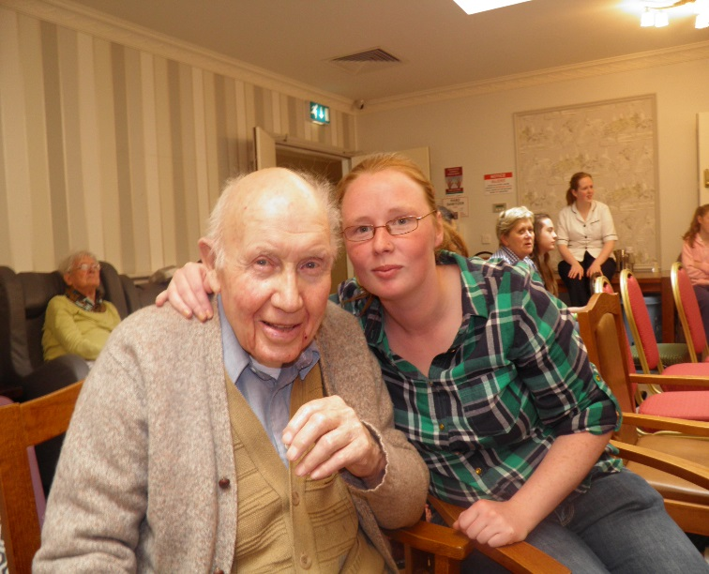
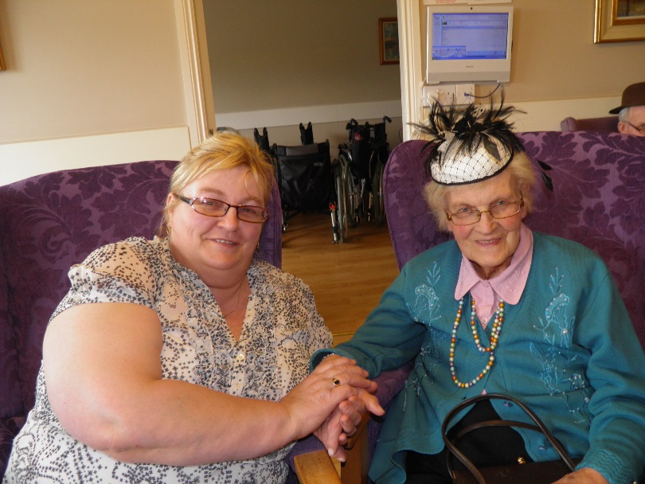
Saturday, 27th June brought the climax of the week with the Country and Western Barbeque. Frank McCaffrey provided the musical entertainment and was a fantastic compere for the afternoon. The catering team in the Nursing Home yet again excelled and put on a display to make everyone’s mouths water. The afternoon was enjoyed by all present and the staff and visitors made huge effort’s to ensure the residents got the most from the day.
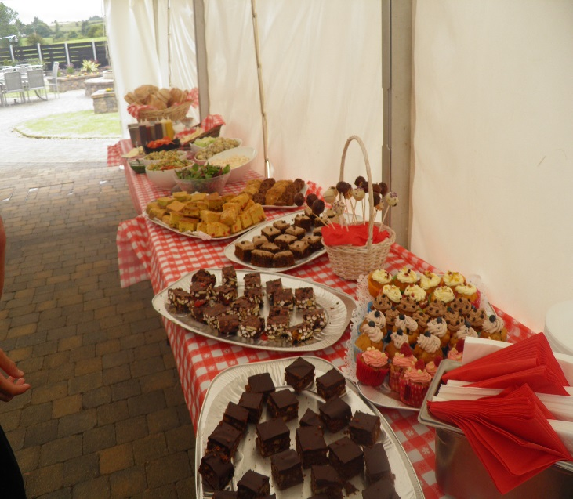
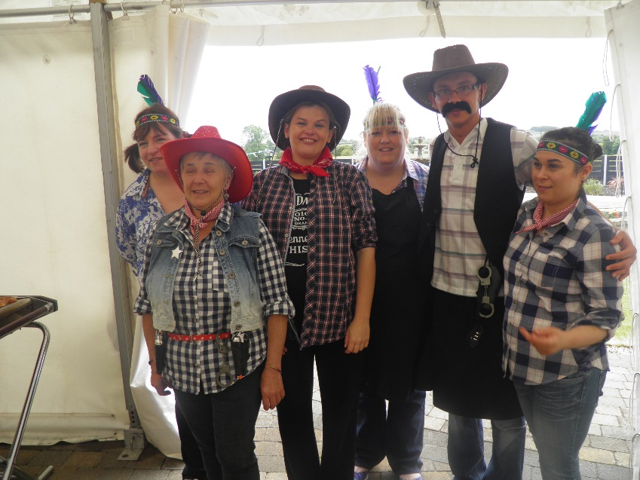
The week also included mass and anointing of the sick, monster bingo, music and dancing, Imagination Gym and Sonas.
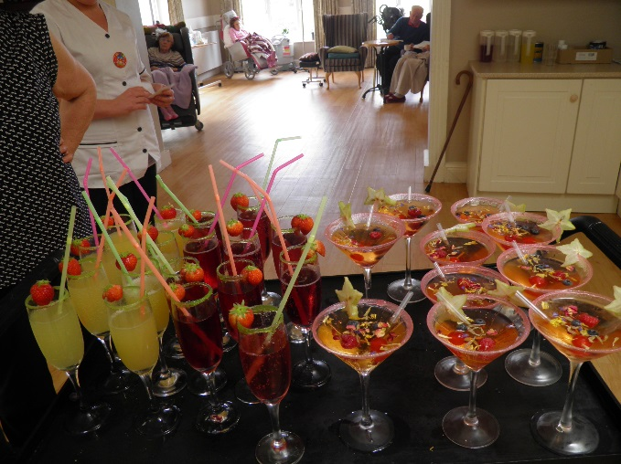
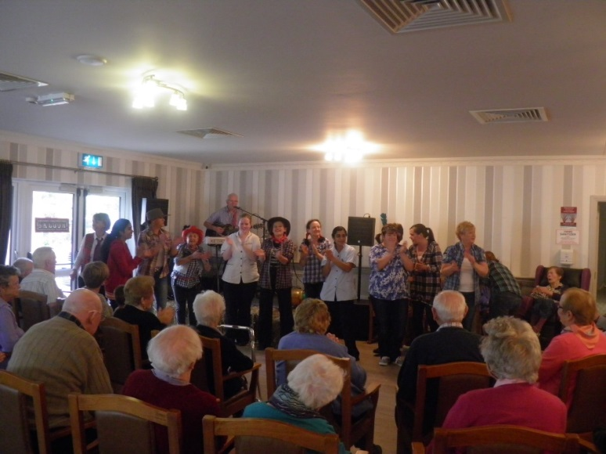

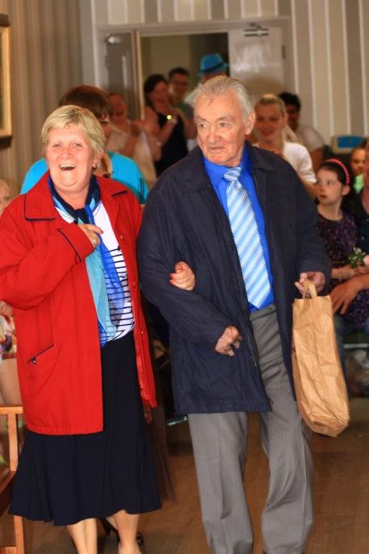
Fashion Show
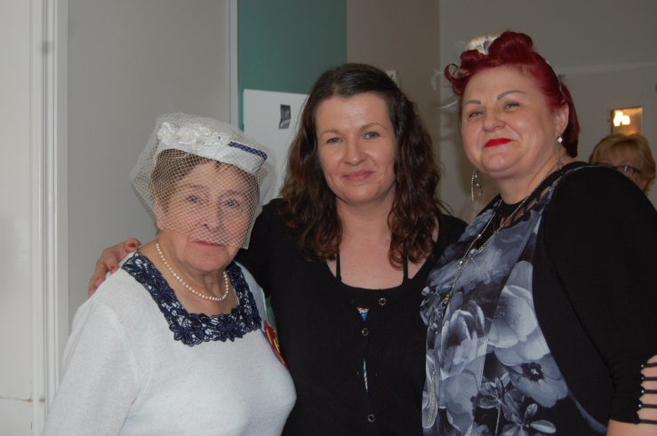
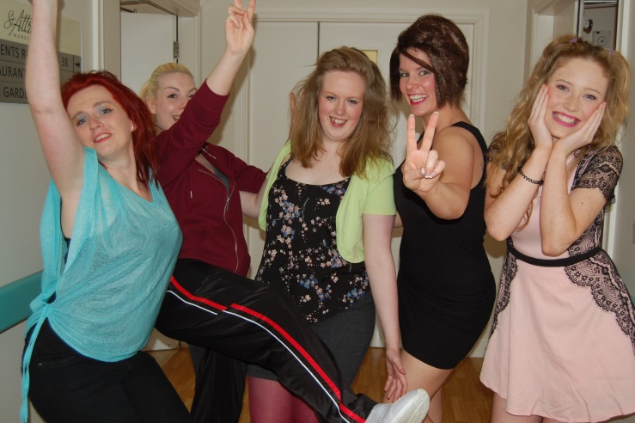
On Wednesday, 7th July 2015 the nursing home held its Fashion & Entertainment Show which ran for the second year. This was a massive gala of entertainment with 25 acts performing. Guests who appeared on the day included Joe Dolan, Tom Jones, The Spice Girls, Gay Byrne, Mrs Brown, characters from Coronation Street and Keeping up Appearances, Dolly Parton & kenny Rodgers and many more. Laurel & Hardy made a comeback to everyone’s delight and were only surpassed by the Eurovision show revisited. The residents participated in a Fashion Show which was definitely one of the high points of the afternoon. The absolute pinnacle of the show was the mock wedding of two of the nursing home residents and the afternoon finished off with some wedding cake, bubbly and vigorous dancing and fun.
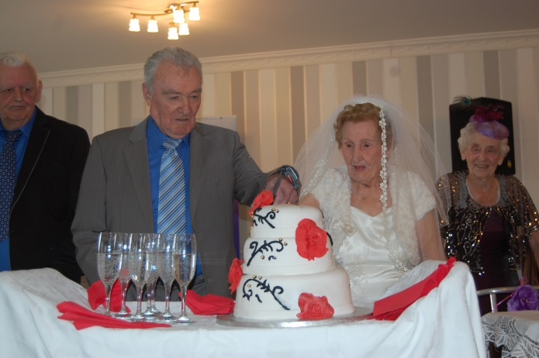
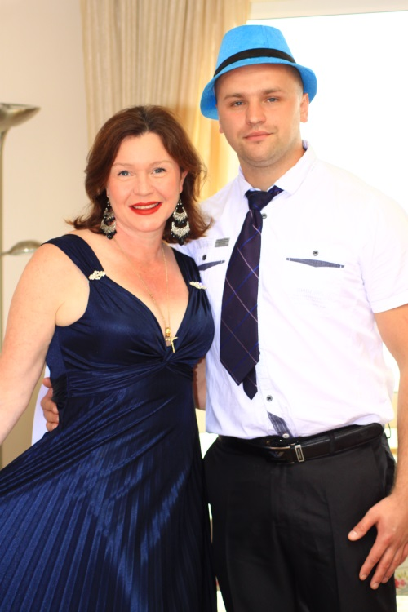
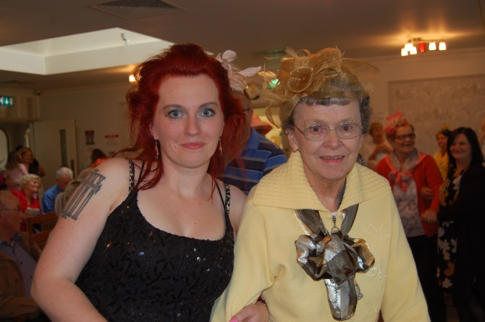
Linen Hall Art Exhibition
On Friday of 29th May as part of the Bealtaine Festival an exhibition of drawings and paintings was launched in the Linen Hall Art Centre Castlebar. All the work on display was part of the “Art Room” arts in care settings programme and amongst the care centres represented was St Attracta’s Nursing Home.
Tom Meskell was the facilitating artist who worked with eight of St. Attractas Nursing Home residents to produce fantastic art displays. Tom’s mum Nuala Meskell who is a resident of St. Attractas was amongst the artists and attended the exhibition on the day. Her fellow artists were: Maureen Walsh, Seamus Fox, Nora Dillon, Teresa Grennan, Kitty Stenson, Chris Davey, Mary O’ Higgins, Mary B McLoughlin, Ann Sandys.
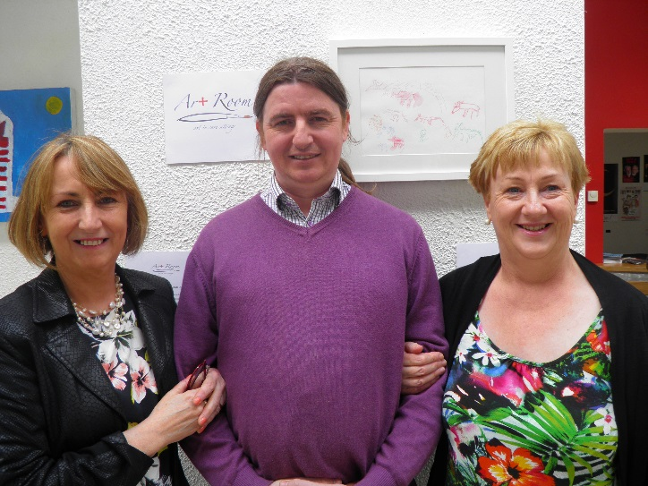
There was a great crowd gathered at the launch, a wonderful atmosphere with staff, family, friends and participants of the art programme marvelling at the wonderful work on display. The work looked beautiful in the Linenhall exhibition space and there were huge complements paid to the hard work and creativity of all those involved. We plan to soon have our own art exhibition and unveiling and the art will then be displayed in the nursing home for all to enjoy.
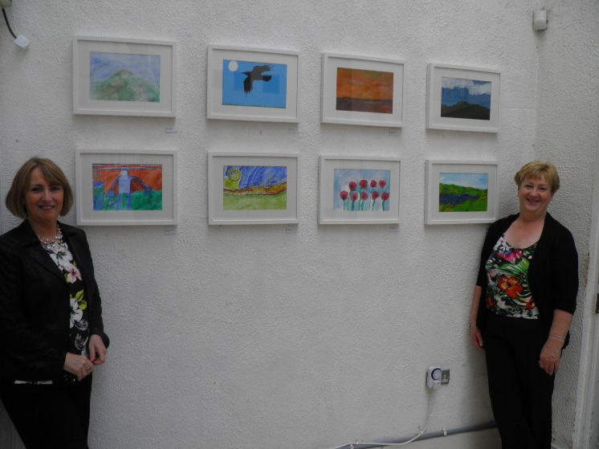
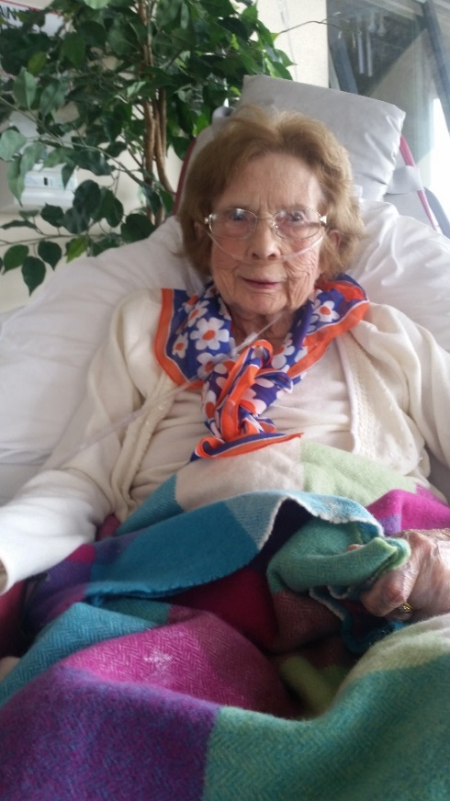
Race Week
The residents donned their finery to celebrate ladies day
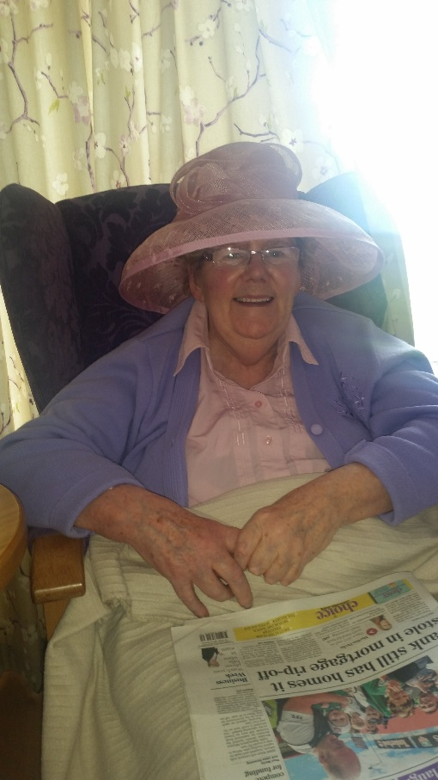
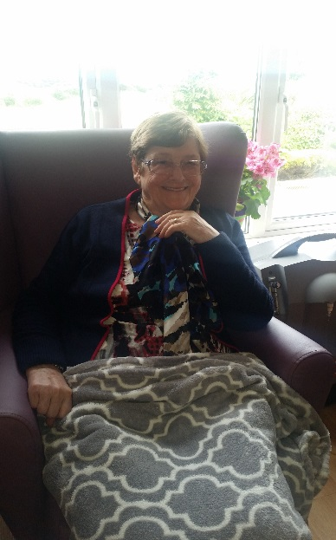
and some even had a flutter on the horses!
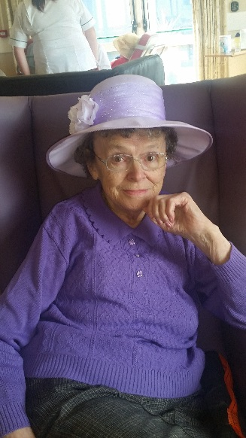

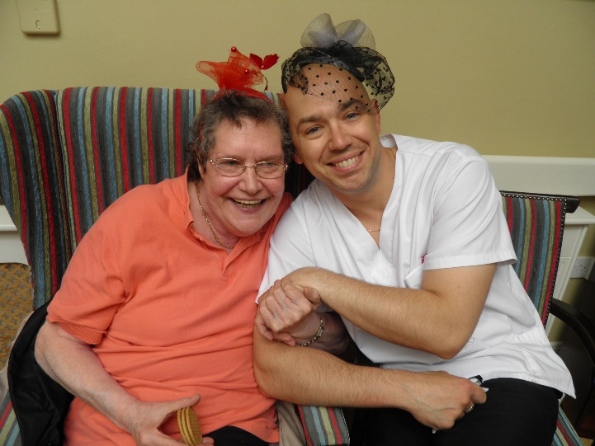

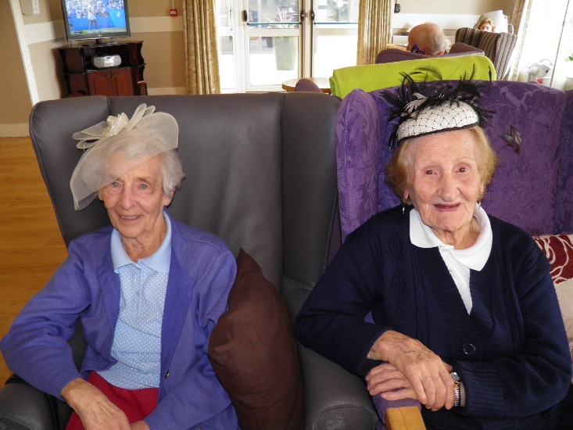

Thought for the Day!!!!!
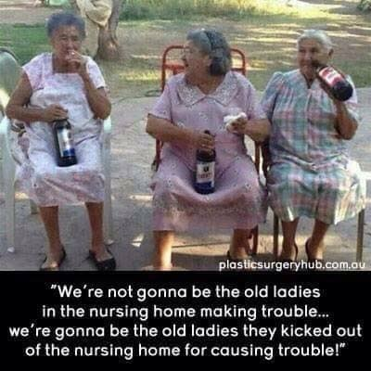
Dates for the Diary
- Thursday, 17th September - Coffee Morning
- Friday, 18th September – World Cup Rugby
- Sunday, 20th September – All Ireland Final Day
- Tuesday, 22nd September – Butterfly Company
- October - Positive Aging Week (Tea day, special visitors and other exciting events)
- Friday, October 2nd – Outing to the pub
- Tuesday, 6th October – Art Exhibition and Cheese & Wine Reception
Welcome
Welcome to the new residents who joined us in recent months; Charlotte Coyle, Vincent Dunleavy, Mary Costello and Maria McHugh. We are delighted to welcome you to your new home and hope you are settling in well.

Birthday Celebrations

We’ve had a lot of birthdays over the past few months. The following residents all celebrated birthdays recently:
John Lavin, 4th May Peggy Stenson, 6th June Mary Gallagher, 6th July
Annie Mai O Donnell, 5th May Annie O’ Hara, 18th June Margaret Moran, 7th July
Mary B McLoughlin, 9th May Nora Dillon, 21st June Bernadette Swords, 6th Aug
Bridie McCann, 16th May Ann Sandys, 21st June James Walsh, 10th Aug
John Moran, 17th May Margaret Killilea, 24th June Ann Keighir, 12th Aug
Sean Brett, 25th May Tommy Carmody, 25th June Maria McHugh, 16th Aug
Jack Pilkington, 28th May Patrick McNulty, 27th June Teresa Grennan, 20th Aug
Margaret Timon 6th June Alice O’ Connell, 29th June

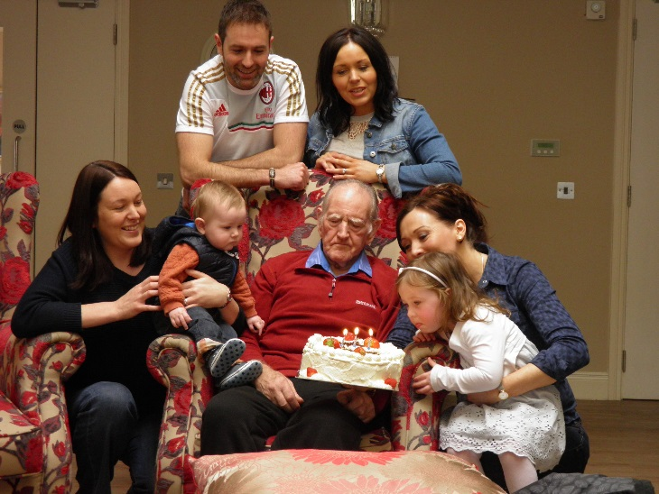
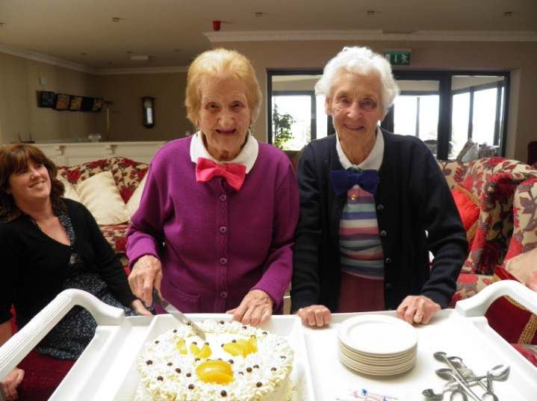
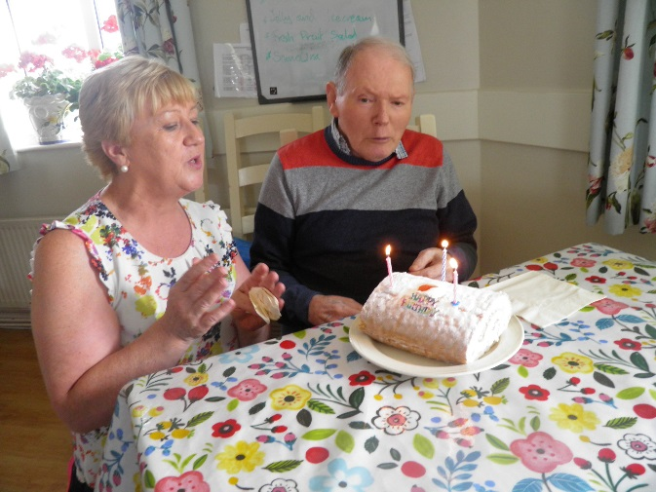
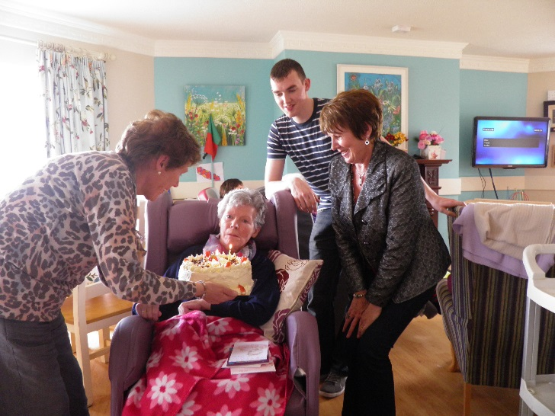
Here is a selection of some of the birthday pics from the recent months!

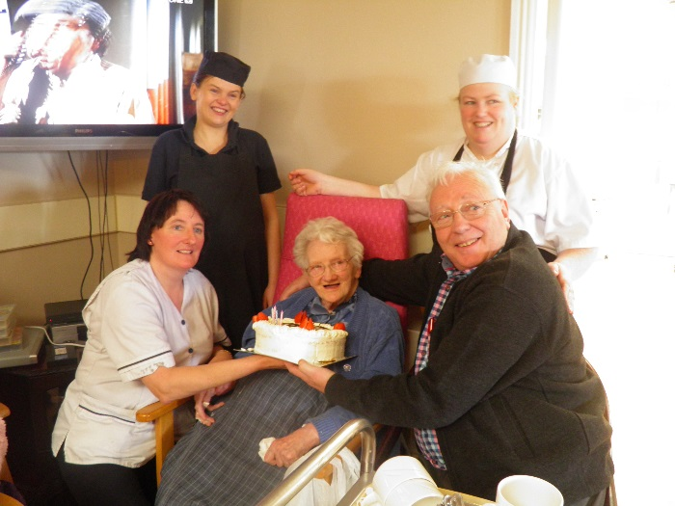
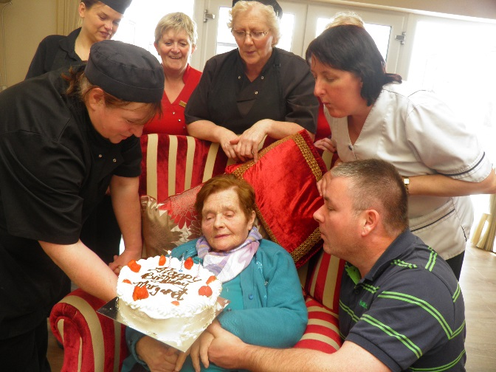

RIP
Deepest sympathy is extended to their family and friends on the recent passing of Denis McDonagh, Peggy Duffy, Bishop Flynn, John Gavaghan and Josie Walsh. May they rest in peace.

Planned Developments
Plans are underway to extend the area which is currently home to the Snug sitting room. The plans include two larger living and dining rooms areas which will give residents more space for movement. In addition the extension will include an activity room and a visitor’s room along with the various other functional rooms like toilets, treatment room, storage and linen rooms. We expect it will be the end of the year before any work commences and will keep you updated with the plans as they progress. As always every effort will be made to ensure the work causes minimal disruption to residents. If you have any feedback or ideas would wish to contribute please talk to any member of the management.
Keep Smiling
It is ever true that sun comes after rain
And we have often proved the fact that joy comes after pain
It’s when the light is breaking through the clouds which made us sad
Our hearts rejoice with peace and love and once again we’re glad
by Jim Keighir

Audit Feedback
The 2014 Annual Review of Quality & Safety of Care has been completed and copies are distributed throughout the nursing home. This is a summary of key aspects of the nursing home service. If you would like more information on any aspects of this document or would like to see other points included in future annual editions please speak with the Director of Nursing, Alison Moore.
The senior management team of the nursing home completed an Audit training program in April which gave additional instruction on the audit processes we use and audit tools. We expect that this will help to enhance the quality of the audits carried out in St. Attracta’s.
In recent months the following audits have been carried out:
- Cleaning Audit, Night Duty Checks, Manual Handling Audit – this was carried out monthly
- Medication Audit – completed to ensure all the practices in management and administration of medication to residents follows the correct procedures.
If you would like more information on monitoring of quality standards at St. Attracta’s Nursing Home please don’t hesitate to ask any member of staff.

St. Attracta’s Team News
We had had a number of new staff join the team in recent months. We heartily welcome these new members to the nursing home team. Farewell to those staff who have left us to move onto pastures new and thank you for your hard work and service.

- Lisa Mulderrig – Healthcare Assistant
- Helena Corcoran – Healthcare Assistant
- Petra Jelsinova - Housekeeper
- Nancy Abraham – Staff Nurse
- Praveen Tuppad – Staff Nurse
- Michelle Gallagher - Healthcare Assistant
- Phillip Wilhelm - Healthcare Assistant
- Kamil Turant – Housekeeper & Maintenance Operative
- Daniel Bogdan - Healthcare Assistant

